Logiware Documentation Standards

Font

Use Arial font 11 for text

Headings and Sub-headings

* + Main Heading 1 should be in Arial, Bold, 16, Logiware Orange
  + Sub-heading 2 should be in Arial, 14, Logiware Blue
  + **Sub-heading 3** should be in Arial, Bold, 12, underlined, Black
  + ***Sub-heading 4*** should be in Arial, Bold, Italic, 11, Black

Notations on Screenshots

Use red circles and rectangles to highlight areas on the screen as shown below:

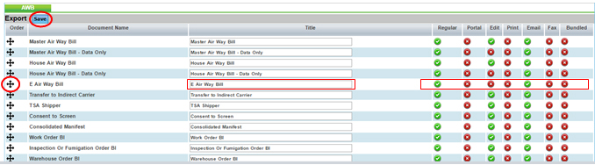

Bullets

Use bullets to list things as shown below – solid bullet and hollow bullet for nested bullets:

* Text for bullet 1.
  + Text for nested bullet
    - Text for nested bullet with a nesting

Number Icons

Use number icons to identify multiple fields or steps/sequence on the screen

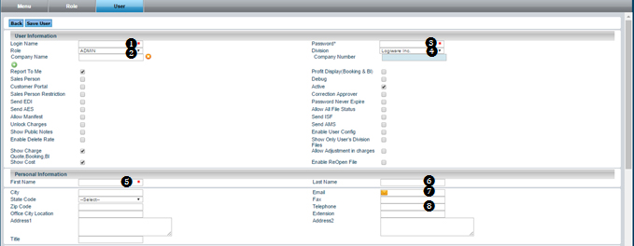

Sample text description:

❶ Make sure the number here matches the one in the image so the user can make the connection easily.

Imbeded icons

Imbed icons Description: http://192.168.1.206:8081/logiware/images/common/icons/app.png in sentences to refer to them.

Tips for providing clear instructions:

* Make effective use of pictures and diagrams.
* Provide step-by-step sequences in the correct order.
* Follow the timing and sequencing of the actual operations .
* Provide visual stepping stones (e.g. Step 1, Step 2 etc.)
* Avoid lengthy paragraphs.
* Use everyday words and terms: avoid jargon.
* Explain what a function or feature is for (in basic practical terms) as well as "How to" instructions.
* Check that the instructions match the actual product.
* Explain symbols, icons and codes early.
* Do not assume the user has prior experience or product knowledge.
* Write in the present tense and the active voice.
* Usability test the instructions alongside the product using naive users (not designers or product experts).
* Write [the steps to task completion](http://www.userfocus.co.uk/articles/redroutes.html) while doing the actual task on a real product.
* Have an independent user then follow the steps (literally) with the product and check that:
  + It is easy to work through the task from start to finish.
  + It is easy to break out of task and get back in.
  + It is easy to jump into the user manual half way through a task.

How to Design a page:

* Ensure that font size is adequate (use at least 11 point font).
* Ensure high text-to-background contrast (black on white is best).
* Use san-serif fonts (Arial).
* Avoid using multiple font styles.
* Font weight can be used sparingly to denote importance.
* Use color coding consistently.
* Provide plenty of white space between sections and around images and paragraphs.
* Use consistent layout from page to page.
* Avoid using saturated blue for text and small detail, and never use blue on a red background.